Centralized Login Portal for BatchHost-Pro & FileBridge System
— Implementation Walkthrough

Overview
This document describes how to build a centralized authentication portal that sits in front of two separate systems — BatchHost-Pro and a second system FileBridge. After a user log in once, they are presented with a selection screen showing both systems as cards. Clicking Login on a system card triggers that system's splash screen and redirects to its dashboard.

Architecture
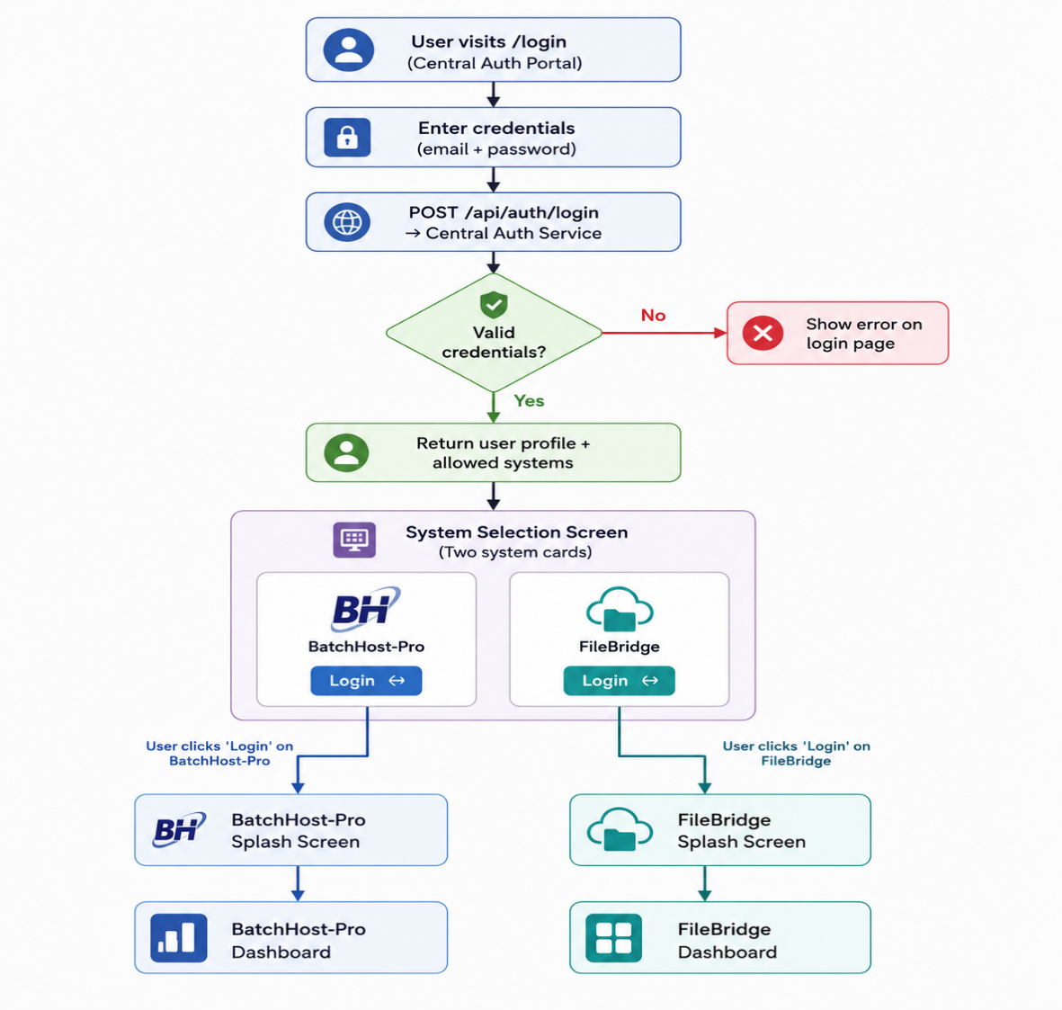

User Roles
Both systems share the same three roles. Role-based access is enforced per system after redirect.

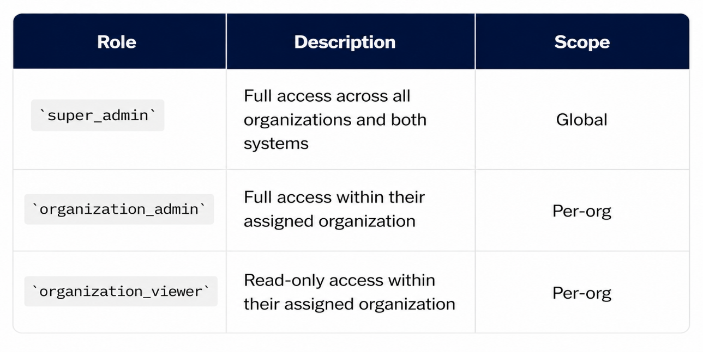

Multi-Organization Support
- Each user belongs to one organization (set at creation time by super_admin).
- `super_admin` users see all organizations' data in both systems.
- `organization_admin` and `organization_viewer` see only their org's data.
- The centralized login must pass the `organization_id` along with the session/token so each system can enforce its own org-level filtering.

Phase 1 — Centralized Auth Service

Shared Session / Cookie (Simpler, same server)
As the both systems run on the same domain, use a shared secret key and a common `users.json`. The central login sets a cookie (`auth_session`) and both Flask apps read it.

- Both apps must use the same `secret_key` for Flask sessions.
- Same-domain cookies are automatically shared.
- Simpler but less scalable.

Phase 2 — Login Page (`portal.html`)
Layout
The login page is identical in look and feel to the existing login page of BatchHost-Pro System — same dark theme, same glass card, same splash screen pattern.

CSS Variables to Reuse
Copy the existing design tokens from base.html of BatchHost-Pro System

```css
:root {
--bg: #0B1220;
--bg2: #111827;
--accent: #3B82F6;
--text: #E5E7EB;
/* ... all existing tokens ... */
}
```

Phase 3 — System Selection Screen (`select.html`)
After a successful login, redirect to `/select`. This page shows two large cards.

Layout
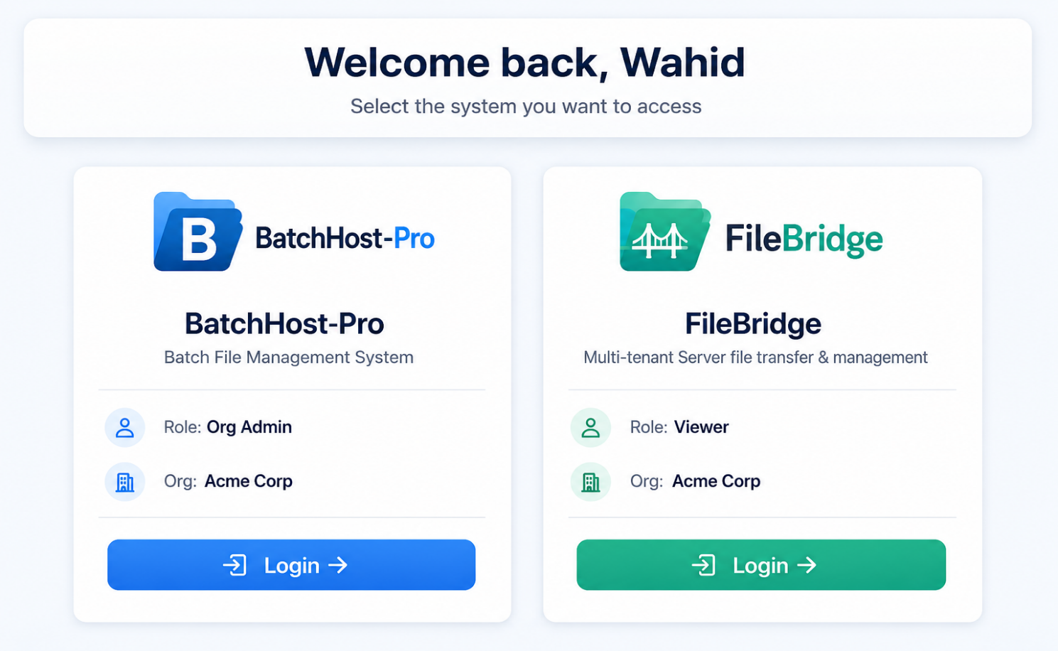

Card Structure (HTML)

```html
<div class="system-cards">
<!-- Card 1: BatchHost-Pro -->
<div class="system-card" id="card-batchhost">
<div class="system-card-logo">
<img src="/images/BatchHost-Pro_logo.png" alt="BatchHost-Pro">
</div>
<div class="system-card-name">BatchHost-Pro</div>
<div class="system-card-desc">Batch File Management &amp; Monitoring</div>
<div class="system-card-meta">
<span class="role-badge organization_admin">Org Admin</span>
<span class="system-card-org">Acme Corp</span>
</div>
<button class="btn btn-primary" onclick="launchSystem('batchhost')">
Login →
</button>
</div>

<!-- Card 2: System B -->
<div class="system-card" id="card-systemb">
<div class="system-card-logo">
<img src="/images/SystemB_logo.png" alt="System B">
</div>
<div class="system-card-name">System B</div>
<div class="system-card-desc">[System B Description]</div>
<div class="system-card-meta">
<span class="role-badge organization_viewer">Viewer</span>
<span class="system-card-org">Acme Corp</span>
</div>
<button class="btn btn-primary" onclick="launchSystem('systemb')">
Login →
</button>
</div>
</div>
```
System Card CSS

```css
.system-cards {
display: grid;
grid-template-columns: repeat(2, minmax(300px, 380px));
gap: 24px;
justify-content: center;
padding: 40px 20px;
}

.system-card {
background: var(--bg2);
border: 1px solid var(--border);
border-radius: 16px;
padding: 36px 28px;
display: flex;
flex-direction: column;
align-items: center;
gap: 14px;
text-align: center;
transition: all 0.25s ease;
cursor: default;
position: relative;
overflow: hidden;
}

.system-card::before {
content: '';
position: absolute;
inset: 0;
background: linear-gradient(135deg, rgba(59,130,246,0.04) 0%, transparent 60%);
opacity: 0;
transition: opacity 0.3s ease;
}

.system-card:hover {
border-color: var(--accent);
transform: translateY(-4px);
box-shadow: 0 20px 40px rgba(0,0,0,0.3), 0 0 0 1px rgba(59,130,246,0.2);
}

.system-card:hover::before { opacity: 1; }

.system-card-logo img {
height: 72px;
width: auto;
filter: drop-shadow(0 4px 16px rgba(59,130,246,0.2));
transition: transform 0.3s ease;
}

.system-card:hover .system-card-logo img {
transform: scale(1.06);
}

.system-card-name {
font-size: 22px;
font-weight: 800;
color: var(--text);
letter-spacing: -0.02em;
}

.system-card-desc {
font-size: 13px;
color: var(--text2);
line-height: 1.5;
}

.system-card-meta {
display: flex;
flex-direction: column;
align-items: center;
gap: 6px;
}

.system-card-org {
font-size: 12px;
color: var(--text3);
font-family: var(--mono);
}

.system-card .btn {
width: 100%;
margin-top: 8px;
padding: 12px;
font-size: 14px;
font-weight: 700;
justify-content: center;
}
```

Phase 4 — System-Specific Splash Screens
When the user clicks Login → on a system card, the flow is:

1. Call `POST /api/auth/launch {system: "BatchHost-Pro”} ` → get `launch_url`
2. Show the target system's splash screen (in-page overlay) for ~1.5 seconds
3. Navigate to `launch_url` (which will trigger the system's own splash on its login redirect)

Per-System Splash Customization
Each system splash uses the same CSS structure as the existing login.html splash screen from BatchHost-Pro System, but with system-specific branding:

Property | BatchHost-Pro | FileBridge
Logo | BatchHost-Pro_logo.png | FileBridge_logo.png
Brand name | BatchHost-Pro | File Bridge
Tagline | Batch File Management System | Multi-tenant Server file transfer & management
Accent colour | #3B82F6 (blue) | #10B981 (emerald)
Glow colour | rgba(59,130,246,0.18) | rgba(16,185,129,0.18)
Progress gradient | Blue → Indigo → Purple | Emerald → Teal → Cyan
Version | v2.0 | v1.0

JavaScript Launch Handler

```javascript
async function launchSystem(systemKey) {
const btn = document.querySelector(`#card-${systemKey} .btn`);
btn.disabled = true;
btn.textContent = 'Launching…';

try {
const r = await fetch('/api/auth/launch', {
method: 'POST',
headers: { 'Content-Type': 'application/json' },
body: JSON.stringify({ system: systemKey })
});
const data = await r.json();

if (data.launch_url) {
// Show system-specific splash
showSplash(systemKey);
// After splash animation (1.5s), navigate
setTimeout(() => {
window.location.href = data.launch_url;
}, 1500);
} else {
flash(data.message || 'Launch failed', 'error');
btn.disabled = false;
btn.textContent = 'Login →';
}
} catch (e) {
flash('Connection error', 'error');
btn.disabled = false;
btn.textContent = 'Login →';
}
}
```

Phase 5 — BatchHost-Pro SSO Endpoint
Add a new route to the existing server.py of BatchHost-Pro System to accept the launch token and create a local session.

```python
@app.route('/auth/sso')
def sso_login():
"""Accept a launch token from the central auth portal."""
token = request.args.get('token')
if not token:
return redirect(url_for('login_page'))

# Verify token with the central auth service
try:
resp = requests.post(
f"{CENTRAL_AUTH_URL}/api/auth/verify-token",
json={"token": token},
timeout=5
)
data = resp.json()
except Exception:
flash_msg = "SSO verification failed"
return redirect(url_for('login_page'))

if not data.get('valid'):
return redirect(url_for('login_page'))

user = data['user']
# Establish Flask session exactly as normal login does
session['user_id'] = user['id']
session['role'] = user['role']
session['organization_id'] = user['organization_id']
session['login_at'] = time.time()

# Mark web presence, log admin action, etc. (same as existing login)
mark_web_presence(user['id'])

# Show splash on BatchHost-Pro's dashboard
return redirect(url_for('dashboard'))
```

> NOTE - The `show_splash` flag can be passed as a query param (`?splash=1`) so the dashboard template knows to show the splash on first load after SSO redirect.

---

Phase 6 — Modified `login.html` for BatchHost-Pro
The existing login.html of BatchHost-Pro System should be kept as-is for direct access fallback (users who go directly to BatchHost-Pro's URL). However, add a banner or redirect:

```html
<!-- Optional: Add to login.html to redirect to central portal -->
<div class="switch-link">
Have multiple systems?
<a href="https://portal.yourdomain.com/login">Use the Central Portal →</a>
</div>
```

Phase 7 — Backend: Central Auth `server.py`

Key Endpoints
```python
# POST /api/auth/login
@app.route('/api/auth/login', methods=['POST'])
def auth_login():
data = request.json
email = data.get('email', '').strip()
password = data.get('password', '')

# Load from shared users.json
users = load_json(USERS_FILE)
user = next((u for u in users if u['email'] == email and u['status'] == 'active'), None)
if not user or not verify_pw(user['password'], password):
return jsonify({'success': False, 'message': 'Invalid credentials'}), 401

session['user_id'] = user['id']
session['role'] = user['role']
session['organization_id'] = user['organization_id']

# Determine which systems this user can access
allowed_systems = get_allowed_systems(user)

return jsonify({
'success': True,
'redirect': '/select',
'user': {
'name': user.get('username'),
'role': user['role'],
'organization': get_org_name(user['organization_id'])
},
'systems': allowed_systems
})

# POST /api/auth/launch
@app.route('/api/auth/launch', methods=['POST'])
@login_required
def auth_launch():
system_key = request.json.get('system')
user = _current_user()

# Generate a short-lived one-use token
token = generate_launch_token(user, system_key)
system_config = SYSTEMS[system_key]

return jsonify({
'launch_url': f"{system_config['base_url']}/auth/sso?token={token}"
})

# POST /api/auth/verify-token (called by target systems)
@app.route('/api/auth/verify-token', methods=['POST'])
def verify_token():
token = request.json.get('token')
payload = consume_launch_token(token) # one-use, 30s TTL
if not payload:
return jsonify({'valid': False}), 401
return jsonify({'valid': True, 'user': payload['user']})
```

Systems Configuration

```python
SYSTEMS = {
'batchhost': {
'name': 'BatchHost-Pro',
'base_url': 'https://batchhost.yourdomain.com',
'logo': '/images/BatchHost-Pro_logo.png',
'description': 'Batch File Management & Monitoring',
'accent': '#3B82F6',
},
'systemb': {
'name': 'System B',
'base_url': 'https://systemb.yourdomain.com',
'logo': '/images/SystemB_logo.png',
'description': 'System B Description',
'accent': '#10B981',
}
}
```

Phase 8 — Role-Based System Access Control
Control which systems a user can see on the selection screen:

```python
def get_allowed_systems(user):
"""Return list of systems a user is allowed to access."""
role = user.get('role')
allowed = []

for key, config in SYSTEMS.items():
# super_admin sees everything
if role == 'super_admin':
allowed.append({**config, 'key': key})
# org roles: check if user's org is registered for this system
elif user['organization_id'] in config.get('allowed_orgs', []):
allowed.append({**config, 'key': key})

return allowed
```

> TIP - Store per-system org allowlists in `settings.json` or a separate `systems.json` file for easy management without code changes.

File Structure Summary

New Files to Create
File | Purpose
auth_portal/server.py | Central auth Flask app
auth_portal/templates/portal.html | Login page (reuses BatchHost-Pro design)
auth_portal/templates/select.html | System selection screen with two cards
auth_portal/data/systems.json | System configuration (URLs, logos, orgs)

Modified Files in BatchHost-Pro
File | Change
server.py | Add /auth/sso route for token exchange
login.html | Add optional "Use Central Portal" link
dashboard.html | Support? splash=1 query param to show splash after SSO

User Flow Summary
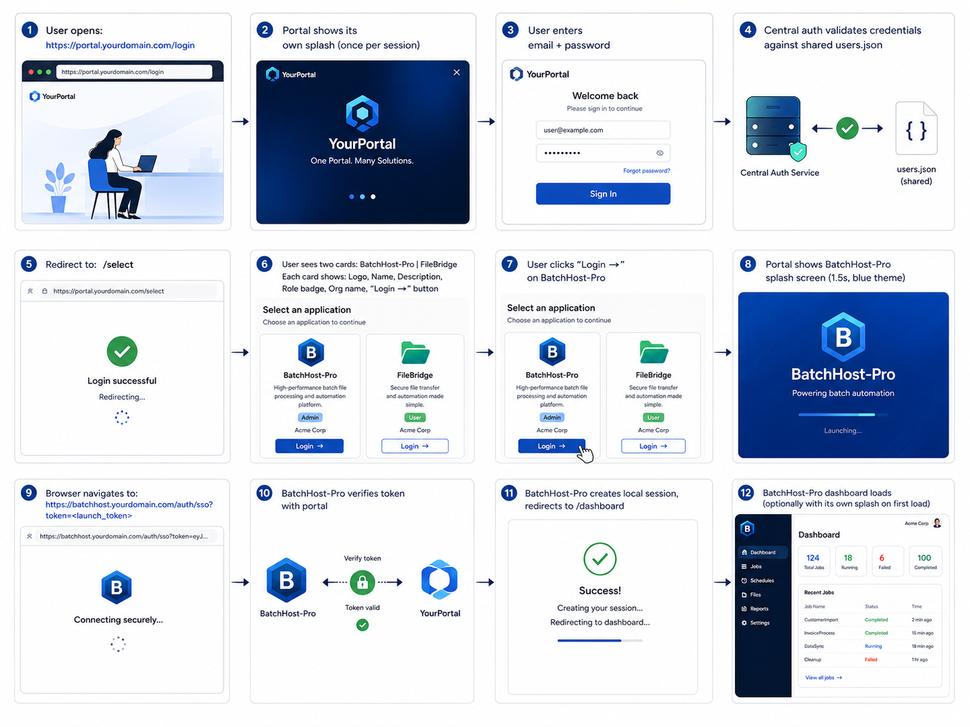

Security Considerations
CAUTIONS: -
- Launch tokens must be one-use and expire in ≤ 30 seconds to prevent replay attacks.
- Communicate between auth portal and target systems over HTTPS only.
- Use the existing CSRF protection pattern from server.py of BatchHost-Pro System on all state-mutating endpoints.
- Never expose the shared `SECRET_KEY` in version control — use environment variables.
- Rate-limit `/api/auth/login` using the existing `rate_limit` decorator from rate_limiter.py of BatchHost-Pro System.

Open Questions
Before implementation begins, clarify the following:

1. Where does System B live? — Same server as BatchHost-Pro
2. Shared or separate user database? —both systems should read from a single `users.json`
3. What is the name & branding of System B? — Name – FileBridge, Logo, color accent, tagline, version – 1.0
4. Do all users have access to both systems? — Yes
5. Session strategy — This system uses stateful, server-side Flask sessions

